Project Report on
Used Car Price Prediction System
A Machine Learning application for estimating used-car selling prices
MAJOR PROJECT REPORT

Submitted in partial fulfillment of the requirements for the degree of
Bachelor of Computer Applications (BCA)
Developed By
Shaikh Sanofar (202312102004)

(Sem – VII Bachelor of Computer Application)

A Project Report On

  - Used Car Price Prediction System

  - Submitted to Faculty of
  - Bachelor of Computer Application


  - In partial fulfillment of the requirement of the award for the degree Of

  - Bachelor Of Computer Applications

Gujarat University
Under the guidance of
Name of Faculty:

Submitted by:

Name | Enrollment no.
Shaikh Sanofar | 202312102004

CERTIFICATE
2. ACKNOWLEDGEMENT

I would like to express my sincere gratitude to my project guide and faculty members for their guidance, suggestions and support during the development of the CarWise – Used Car Price Prediction System. Their guidance helped me understand the practical application of machine learning concepts.

I am also thankful to my college for providing the opportunity to work on this project as part of the BCA curriculum. I acknowledge the developers and maintainers of Python and its open-source libraries, including Pandas, Scikit-learn, Joblib and Streamlit, which supported the development of this application.

Finally, I thank my family and friends for their encouragement and support throughout the project.

Student Name : Shaikh Sanofar Khwaja Aamin.
Class / Semester: BCA Sem 7
Roll Number : 4033
Date : 30-10-2026

INDEX
Sr. No. | Contents | Page No.
1 | College Certificate | 3
2 | Acknowledgement | 4
3 | Index Page | 5
4 | Introduction | 6
5 | Dataset Selection | 7
6 | Data Preprocessing | 8
7 | Exploratory Data Analysis (EDA) | 9
8 | Visualization Using Matplotlib and Seaborn | 10
9 | Model Building and Training | 11
10 | Model Evaluation and Performance Metrics | 14
–11 | Advanced Techniques and Pattern Discovery | 15
12 | Conclusion and Future Work | 16
13 | Application Screenshots | 17
14 | Bibliography | 18

INTRODUCTION

CarWise is a web-based used-car price estimation application developed with Python and Streamlit. It uses historical used-car data to train a machine learning regression model and estimates a car's selling price from selected vehicle attributes. The application also provides dataset exploration, basic data analysis, model performance information and project details.

  - Problem definition

The selling price of a used car depends on several factors, including its manufacturing year, kilometres driven, fuel type, transmission, seller type and ownership history. Estimating a fair price manually can be difficult because these factors interact and prices vary across vehicles. The problem addressed by this project is to build a data-driven system that estimates the selling price of a used car from historical examples.

  - Objective of project

- Study and explore a real-world used-car dataset.
- Prepare the data for machine learning.
- Analyse price patterns using summary statistics and visualisations.
- Build regression models that estimate a numerical selling price.
- Evaluate models using appropriate regression metrics.
- Apply at least one pattern-discovery technique, such as K-Means clustering.
- Provide a simple web interface for entering vehicle details and viewing an estimate.

  - Scope

The system is intended for academic demonstration and preliminary price estimation. It is not a professional vehicle valuation service and does not inspect the physical condition of a vehicle, regional market changes, accident history or all optional features. The estimate should therefore be treated as an approximate value rather than a guaranteed market price.

  - Problem Type

This is a supervised regression problem because the target variable, selling_price, is numerical. The model learns a relationship between vehicle attributes (features) and historical selling prices (target) and uses that relationship to predict a price for a new input.

5. DATASET SELECTION

The project uses the CSV file named “CAR DETAILS FROM CAR DEKHO.csv”. The file is placed in the same project directory as app.py and train_model.py. The dataset is associated with used-car listings and contains vehicle attributes and selling-price information.
Dataset source/reference: [Insert the exact Kaggle or other source page URL used to obtain the CSV, along with the author/uploader and access date].

5.2 Feature description

Column | Decription | Role | Value to confirm from the actual csv
name |  | Descriptive; not used by current app model
year |  | Feature
selling_price |  | Target
km_driven |  | Feature
fuel |  | Feature
seller_type |  | Feature
transmission |  | Feature
owner |  | Feature

6. DATA PREPROCESSING

Data preprocessing converts the raw dataset into a form suitable for model training. The training script should apply the same preprocessing consistently during training and prediction.

6.1 Data Loading and Column Names
Pandas is used to read the CSV file. Column labels are stripped of extra spaces and converted to lowercase in the Streamlit application so that column references remain consistent.

6.2 Missing Values
Missing values should be counted and inspected. The current training workflow removes rows with missing values in the expected training columns. The number of rows before and after cleaning should be recorded from the actual training run.

Preprocessing check | Before cleaning | After cleaning
Rows
Missing values in selected columns
Duplicate rows (if checked)

6.3 Categorical Encoding

The features fuel, seller_type, transmission and owner contain categories rather than continuous numbers. The training pipeline uses OneHotEncoder with handle_unknown='ignore' to represent categories numerically and to handle categories not encountered during training.

7. EXPLORATORY DATA ANALYSIS (EDA)

Exploratory Data Analysis is used to understand the dataset's structure, distribution, possible outliers and relationships before model training.

7.1 Univariate Analysis

Exploratory Data Analysis is used to understand the dataset's structure, distribution, possible outliers and relationships before model training.

7.2 Bivariate Analysis
Bivariate analysis studies the relationship between two variables. In this project, useful examples include selling_price versus year, selling_price versus km_driven, average selling_price by fuel type, and average selling_price by transmission.

7.3 Statistical Summary
Bivariate analysis studies the relationship between two variables. In this project, useful examples include selling_price versus year, selling_price versus km_driven, average selling_price by fuel type, and average selling_price by transmission.

Statistic | Meaning
Count | Number of non-missing observations
Mean | Arithmetic average
Standard deviation | Measure of spread around the mean
Minimum / Maximum | Smallest and largest observed values
25%, 50%, 75% | Quartiles; 50% is the median

7.4 Correlation Analysis
Correlation analysis measures the strength and direction of linear association between numerical variables. A correlation matrix and heatmap may be created for numerical columns. Correlation does not prove causation, and categorical columns need suitable encoding before they can be included in some correlation calculations.

8. VISUALIZATION USING MATPLOTLIB AND SEABORN

Matplotlib and Seaborn are commonly used Python libraries for statistical visualisation. The current Streamlit application uses Streamlit chart functions for several on-screen charts. To meet the report requirement explicitly, create and include Matplotlib/Seaborn figures in the analysis or notebook/script and insert the resulting screenshots or images here

Suggested figure | Purpose | What to interpret
Selling price histogram (Matplotlib/Seaborn) | Inspect price distribution | Skewness, concentration and extreme values
Box plot of selling_price | Inspect spread/outliers | Median, quartiles and possible outliers
Scatter plot: year vs selling_price | Explore association | Whether newer cars tend to have higher prices in this dataset
Scatter plot: km_driven vs selling_price | Explore association | Whether higher mileage is associated with lower prices
Count plot: fuel / transmission | Compare category frequencies | Which categories are common in the dataset
Correlation heatmap | View numerical correlations | Direction and strength of pairwise linear relationships

8. MODEL BUILDING AND TRAINING

8.1 Model Selection
Since selling_price is numerical, regression algorithms are appropriate. The assignment asks for at least three algorithms to be implemented and compared. The current CarWise application uses a Random Forest Regressor. For a complete comparative study, the training script should additionally train and evaluate Linear Regression and Decision Tree Regressor (or K-Nearest Neighbours Regressor).

Algorithm | Basic idea | Expected role in this project
Linear Regression | Fits a linear relationship between features and target | Simple baseline model
Decision Tree Regressor | Learns rule-based splits to predict a number | Captures non-linear patterns
Random Forest Regressor | Combines predictions from multiple decision trees | Current model used by CarWise
KNN Regressor (optional alternative) | Predicts using nearby training examples | Alternative model for comparison

8.2 Linear Regression
Linear Regression estimates a numerical target using a weighted combination of input features. It is simple and interpretable, but its performance may be limited when the relationship between vehicle features and price is highly non-linear.

8.3 Decision Tree Regressor
A Decision Tree Regressor divides the data into groups using feature-based rules and predicts a numerical value in each terminal region. It can model non-linear relationships but may overfit if the tree is allowed to grow too deeply.

8.4 Random Forest Regressor
Random Forest trains multiple decision trees on sampled data and combines their predictions. It often captures complex relationships better than a single tree, although its actual performance must be confirmed by test-set evaluation.

8.5 Model Training and Testing
Each algorithm should be trained on the same training split and evaluated on the same held-out test set to make the comparison fair. Preprocessing should be included in the pipeline for each model.

8.6 Basic Hyperparameter Tuning
Hyperparameter tuning means testing different settings that are selected before model fitting. For a Decision Tree or Random Forest, examples include max_depth and min_samples_leaf. For KNN, n_neighbors can be tuned. A validation set or cross-validation should be used for selecting settings, and the final test set should remain reserved for final evaluation.

8.7 Best Model Selection
For a regression problem, compare models using MAE, RMSE and R² on the same test set. A lower MAE or RMSE indicates smaller average errors, while a higher R² generally indicates that more target variation is explained. The best model should be selected from actual results, not assumed in advance.
Model | MAE (₹) | RMSE (₹) | R² Score | Tuned settings / notes
Linear Regression | [Run and enter] | [Run and enter] | [Run and enter] | [Enter]
Decision Tree Regressor | [Run and enter] | [Run and enter] | [Run and enter] | [Enter]
Random Forest Regressor | [Run and enter] | [Run and enter] | [Run and enter] | [Enter]

9. MODEL EVALUATION AND PERFORMANCE METRICS

Matplotlib and Seaborn are commonly used Python libraries for statistical visualisation. The current Streamlit application uses Streamlit chart functions for several on-screen charts. To meet the report requirement explicitly, create and include Matplotlib/Seaborn figures in the analysis or notebook/script and insert the resulting screenshots or images here.
Suggested figure | Purpose | What to interpret
Selling price histogram (Matplotlib/Seaborn) | Inspect price distribution | Skewness, concentration and extreme values
Box plot of selling_price | Inspect spread/outliers | Median, quartiles and possible outliers
Scatter plot: year vs selling_price | Explore association | Whether newer cars tend to have higher prices in this dataset
Scatter plot: km_driven vs selling_price | Explore association | Whether higher mileage is associated with lower prices
Count plot: fuel / transmission | Compare category frequencies | Which categories are common in the dataset
Correlation heatmap | View numerical correlations | Direction and strength of pairwise linear relationships

9. MODEL BUILDING AND TRAINING

9.1 Model Selection
Since selling_price is numerical, regression algorithms are appropriate. The assignment asks for at least three algorithms to be implemented and compared. The current CarWise application uses a Random Forest Regressor. For a complete comparative study, the training script should additionally train and evaluate Linear Regression and Decision Tree Regressor (or K-Nearest Neighbours Regressor).
Algorithm | Basic idea | Expected role in this project
Linear Regression | Fits a linear relationship between features and target | Simple baseline model
Decision Tree Regressor | Learns rule-based splits to predict a number | Captures non-linear patterns
Random Forest Regressor | Combines predictions from multiple decision trees | Current model used by CarWise
KNN Regressor (optional alternative) | Predicts using nearby training examples | Alternative model for comparison

9.2 Linear Regression
Linear Regression estimates a numerical target using a weighted combination of input features. It is simple and interpretable, but its performance may be limited when the relationship between vehicle features and price is highly non-linear.

9.3 Decision Tree Regressor
A Decision Tree Regressor divides the data into groups using feature-based rules and predicts a numerical value in each terminal region. It can model non-linear relationships but may overfit if the tree is allowed to grow too deeply.

9.4 Random Forest Regressor
Random Forest trains multiple decision trees on sampled data and combines their predictions. It often captures complex relationships better than a single tree, although its actual performance must be confirmed by test-set evaluation.

9.5 Model Training and Testing
Each algorithm should be trained on the same training split and evaluated on the same held-out test set to make the comparison fair. Preprocessing should be included in the pipeline for each model.

9.6 Basic Hyperparameter Tuning
Hyperparameter tuning means testing different settings that are selected before model fitting. For a Decision Tree or Random Forest, examples include max_depth and min_samples_leaf. For KNN, n_neighbors can be tuned. A validation set or cross-validation should be used for selecting settings, and the final test set should remain reserved for final evaluation.

9.7 Best Model Selection
For a regression problem, compare models using MAE, RMSE and R² on the same test set. A lower MAE or RMSE indicates smaller average errors, while a higher R² generally indicates that more target variation is explained. The best model should be selected from actual results, not assumed in advance.

Model | MAE (₹) | RMSE (₹) | R² Score | Tuned settings / notes
Linear Regression | [Run and enter] | [Run and enter] | [Run and enter] | [Enter]
Decision Tree Regressor | [Run and enter] | [Run and enter] | [Run and enter] | [Enter]
Random Forest Regressor | [Run and enter] | [Run and enter] | [Run and enter] | [Enter]

11. ADVANCED TECHNIQUES AND PATTERN DISCOVERY

11.1 Feature scaling and K-Means
The notebook standardizes the input features using StandardScaler. It then applies KMeans K-Means is an unsupervised learning algorithm that groups observations into a chosen number of clusters. Unlike regression, clustering does not require a target label. For this dataset, K-Means can be explored using scaled numerical attributes such as year, km_driven and selling_price. Categorical features should not be fed directly into standard K-Means without suitable encoding.

11.2 Proposed Procedure
- Select relevant numerical columns and remove or handle missing values.
- Scale numerical features so that large units, such as price, do not dominate solely because of scale.
- Choose a candidate number of clusters (K), using a method such as the elbow plot as one guide.
- Fit K-Means and add each record's cluster label to the analysis data.
- Visualise clusters using a scatter plot, for example kilometres driven against selling price, with points grouped by cluster.
- Summarise each cluster and interpret its characteristics using actual cluster statistics.

11.3 Cluster interpretation

Insert the actual K-Means visualisation here. After running clustering, describe the observed groups using their average price, typical manufacturing year and kilometres driven. Do not label a cluster as “budget”, “premium” or “high mileage” unless the cluster statistics support that interpretation.

12. CONCLUSION & FUTURE WORK

12.1 Conclusion
CarWise demonstrates how a machine learning regression model can be connected to a simple web application for used-car price estimation. The project combines dataset handling with Pandas, model development using Scikit-learn, model persistence using Joblib and a user interface created with Streamlit. Dataset analysis and model evaluation help users inspect the data and understand the limitations of the estimate.
The final conclusions about model quality should be based on the actual test-set MAE, RMSE and R² results. The comparative algorithm and clustering requirements should be considered complete only after the additional experiments have been run and their results recorded.

12.2 Future work
- Compare multiple regression algorithms and tune their hyperparameters.
- Evaluate additional useful features, including vehicle make/model, if the data supports them.
- Add RMSE and cross-validation results to the performance page.
- Implement K-Means clustering and present interpretable cluster summaries.
- Update the dataset with more recent and representative vehicle listings.
- Improve input validation and test edge cases.
- Deploy the application to a suitable hosting platform.

13. Application Screenshots

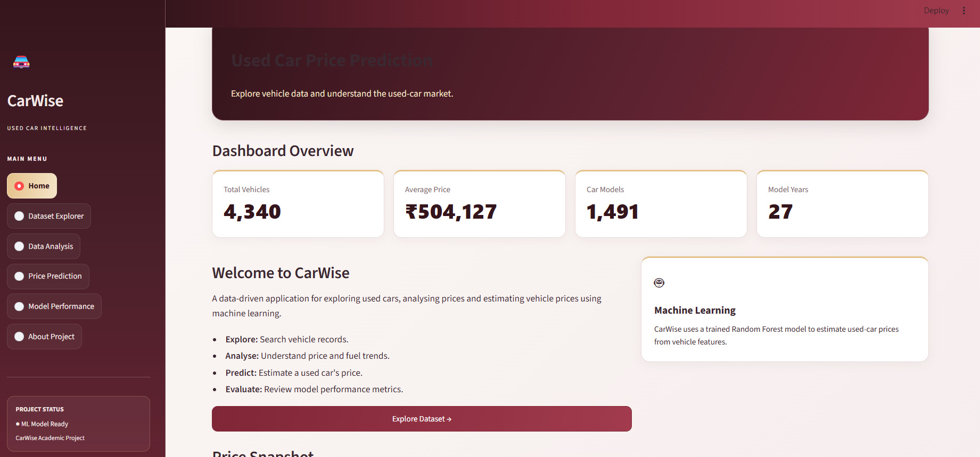

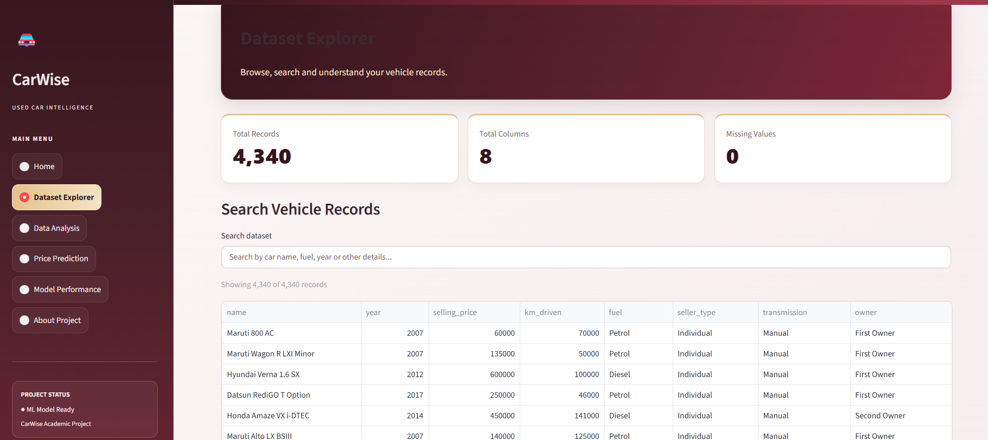

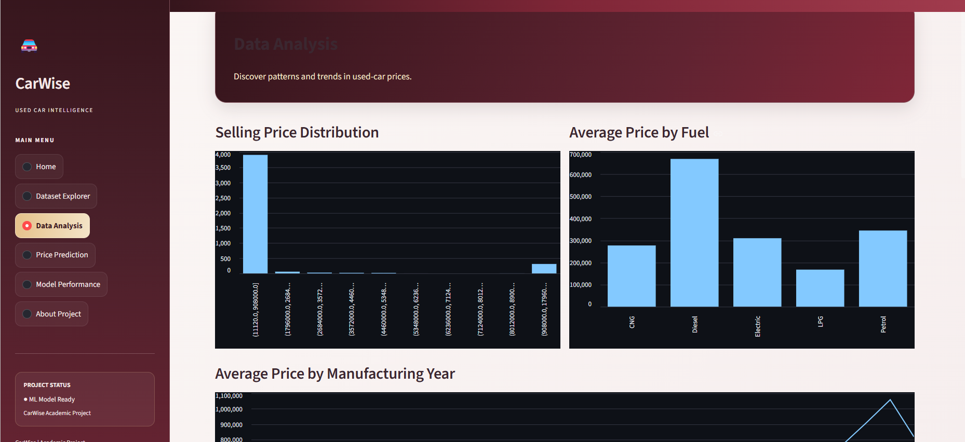
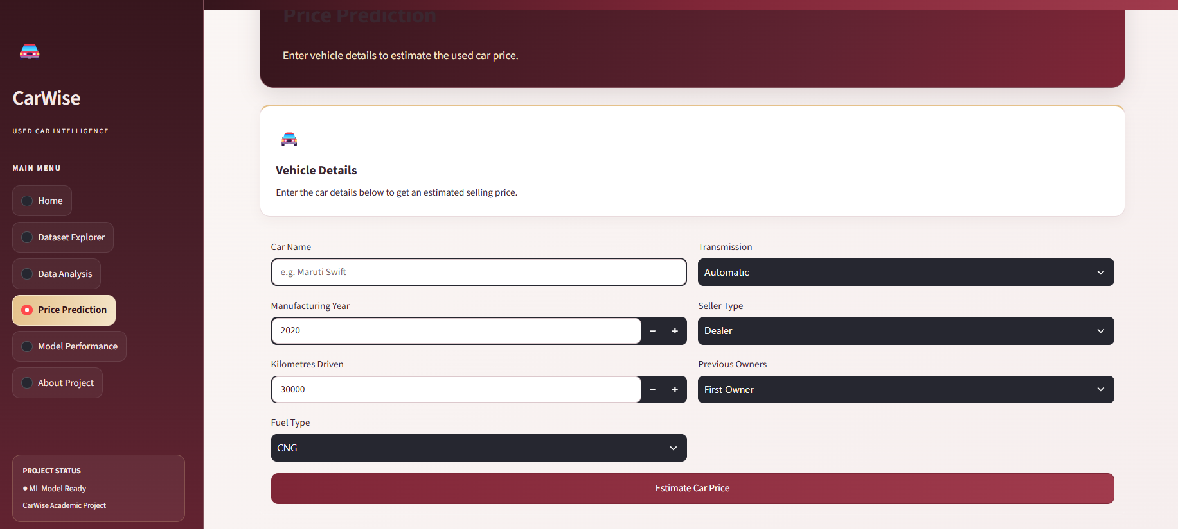

14. BIBLIOGRAPHY

- Pandas Documentation. https://pandas.pydata.org/docs/
- Scikit-learn Documentation. https://scikit-learn.org/stable/
- Streamlit Documentation. https://docs.streamlit.io/
- Joblib Documentation. https://joblib.readthedocs.io/
- Matplotlib Documentation. https://matplotlib.org/stable/
- Seaborn Documentation. https://seaborn.pydata.org/
- [Insert the exact dataset source page URL, dataset author/uploader and access date.]

